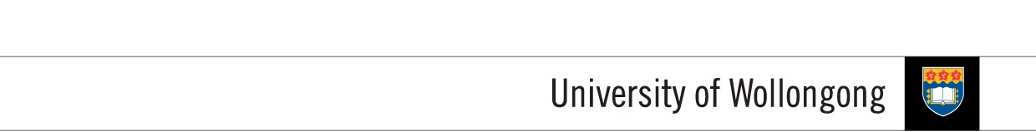

**FACULTY OF INFORMATICS**

|  |  |  |  |
| --- | --- | --- | --- |
| **SUBJECT’S INFORMATION:** | | | |
| Subject: | CSCI124 Applied Programming | | |
| Session: | July 2014 | | |
| Programme / Section: | J766SENG (SE) / J766CS53 (MGD) / J766CS42 (DSS) | | |
| Lecturer: | Ms. Siti Hawa | | |
| Coursework Type  *(tick appropriate box)* | ❑ Individual Assignment ❑ Group Assignment ❑ Project  ✓Lab Task ❑ Seminar / Tutorial Paper ❑ Others | | |
| Coursework Title: | **Lab Task 4** | Coursework Percentage: | 2% |
| **ASSESSMENT CRITERIA:** | | | |
| Correctness | All programs should produce the correct result as stated in the specification. | | |
| Coding | Programs should use appropriate control structures and data structures correctly based on what have been covered in the class and stated in the specification. Necessary input validations should be done. | | |
| Readability | Appropriate comments are included. Meaningful identifiers used. Proper indentation and line spacing used. | | |
| Well formatted output | Output should be well formatted with appropriate messages displayed. Numbers are shown with appropriate precision. | | |
| **SUBMISSION:** | | | |
| All completed work should be submitted online through Moodle before or on the due date provided.  **SUBMIT AS EARLY AS POSSIBLE. YOU CAN RE-SUBMIT LATER IF NECESSARY. ONLY THE LATEST SUBMISSION WILL BE MARKED.**  **IF YOU SUBMIT YOUR ASSIGNMENT TWICE, ONE SUBMMISSION BEFORE THE DUE DATE AND ANOTHER AFTER THE DUE DATE, THEN YOU WILL BE PENALIZED FOR LATE SUBMISSON.** | | | |
| DUE DATE: | **WEEK 6** | | |
| **PENALTIES FOR LATE SUBMISSION:** | | | |
| Penalties apply to all late work, except if student academic consideration has been granted. Late submissions will attract a penalty of 25% of the assessment mark per day including the weekend. Work more than (3) days late will be awarded a mark of zero. | | | |
| **PLAGIARISM:** | | | |
| **When you submit an assessment task, you are declaring the following**   1. It is your own work and you did not collaborate with or copy from others. 2. You have read and understand your responsibilities under the University of Wollongong's policy on plagiarism. 3. You have not plagiarised from published work (including the internet). Where you have used the work from others, you have referenced it in the text and provided a reference list at the end ot the assignment.   Plagiarism will not be tolerated. Students are responsible for submitting original work for assessment, without plagiarising or cheating, abiding by the University’s policies on Plagiarism as set out in the University Handbook under University Policy Directory and in Faculty handbooks and subject guides. | | | |

**COURSEWORK SPECIFICATION**

**OBJECTIVES:**

In the previous lab task, you have done some coding on reading and writing to binary files. This week, you are going to explore the use of binary files using random access.

**TASKS**

You are required to write a program that maintains data about the amount of rainfall for a city using binary file. Each record should be saved into a struct with the following declarations:

struct Rainfall

{

char month[10];

int daysWithRain;

float avgRainfall;

};

Prompt the user to enter several records and saved them to the file. Then provide several options for the user to choose from:

* Display the month with the highest average rainfall.
* Display the month with the highest number of days with rain.
* Display a particular record by prompting the record number from the user. Your program should directly access the record and display it to the user.
* Display a particular record by prompting the month from the user.

The user should be allowed to repeatedly perform several operations on this file and the file should remain open until the user decided to terminate the program.